Appendices

Appendix 1: Technical Specification

Appendix 2: Technical Offer based on Technical Specifications

Appendix 3: Supplier Questionnaire

Appendix 4: Detailed Pricing Matrix

Appendix 5: The AHA Centre’s Good Business Regulations

Appendix 1:

Technical Specification
All supplied items will have to be compliant with international and national standards and norms, and to be adapted to the extreme conditions, they will be used in a humid environment.
Categories: |  | BSM
Product Code: |  | TRP
Product Name: |  | Tarpaulin
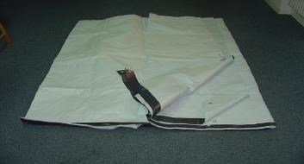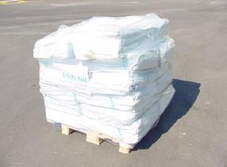
Picture
1
Pallet co
ntains 10 bales
SHIPPING INFORMATION |  |  | Length: | 1.20 m | Net Weight: | 47 kg
 |  |  | Width: | 0.80 m | Gross Weight:
 |  |  | Height: | 0.10 m | Volume: | 0,01 m3
GENERAL INFORMATION
This item is used mainly for temporary human shelter or other personal protection purposes. Supplied in 4mt x 60mt width sheets and equipped with double rows of strong aluminium eyelets at 1m intervals so, if required, they can be cut into individual sheets. Type: Reinforced (braided) flexible sheeting
Colour: white
Material: Low density polyethylene (LDPE) Sheet, reinforced with a scrim of Polypropylene (PP) weave. Reinforced also with 6 fixing bands of 7.5cm width made of woven HDPE fabric. Temperature resistant from -20°c to +80°c.
TECHNICAL INFORMATION
 | Materials: | Low density polyethylene (LDPE)Sheet
 | Size: | LxW = 4x60 m
 | Unit: | Sheet
 | Source: | -
 | Brand: | -
 | Other Info: | -
Categories: | BSM
Product Code: | TKS
Product Name: | Toolkit Shelter
SHIPPING INFORMATION | Length: 1100 mm Net Weight:  Width: 250 mm Gross Weight:  Height: 100 mm Volume:
GENERAL INFORMATION | Tool Kit Shelter comes in a bag, duffle type, coated polyethylene 180g/m2, 300x1400mm, with the ASEAN logo on the cover. contains of: Hoe + Handle= 1pc; Shovel round point with Y handle, 1070mm +/- 50mm= 1 pc; Mut Hoe (Use Hoe Handle) =1 pc; Claw Hammer 750 gram=1 pc; Shears=1 pc; Handsaw 55cm for timber=1 pc; Manchette =1pc; Tie wire galvanized, diam.1.5mm, 25m/roll=1 roll.; Rope dia 3 mm 30m/roll= 1roll; Rope Polypropylene, black; diam.12mm, twisted 30m/roll= 1 roll; Nail for wood 7.5 cm= 500 gram; Nails for wood 4 cm = 500 gram; Roofing Nails with Washer 7.5 cm=500 gram;  The Bag will be with 3 Logos: ASEAN, JAIF and Japan Flag
TECHNICAL INFORMATION | Materials: NA  Size: NA  Unit: kit  Source: NA  Brand: NA

Category: | BSM
Product Code: | FK
Product Name: | Family Kit
 | 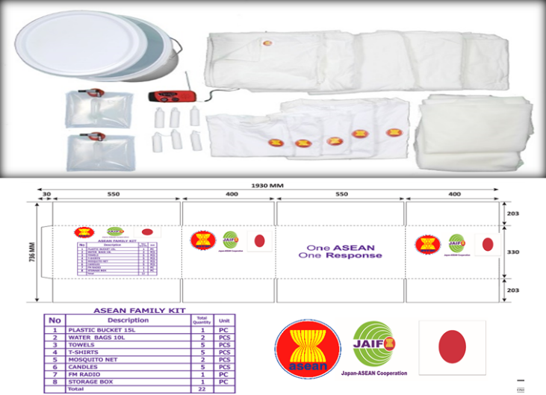
SHIPPING INFORMATION | Length: 550 mm Net Weight: 6,5 kg  Width: 400 mm Gross Weight: 7 kg  Height: 380 mm Volume: 0,0836 m3
GENERAL INFORMATION | Family kit is an essential emergency non-food item supplied in the first phase of an emergency to fulfil the basic Family needs of a family of 5 people.  Contents Units:  - Plastic Bucket 15 litres (medium) x 1 pc  - Water Bags 10 litres x 2 pcs  - Bath towels Length: 140cm x Width: 75 cm with plain white colour 5 pcs  - T-shirts 5 pcs (2 Adults, 3 Children) all size with Embroider ASEAN’s logo in front and letter of One ASEAN One Response on the back side  - Mosquito Net (1800mm x 1600 mm) x 2 pcs  - Candles with 15 – 20 cm (medium) x5pcs  - FM Radio with flashlight x1pc  - Transparent Plastic Container where we can put all the items inside  All the cartoon boxes should be with 3 logos: ASEAN, JAIF and Japan flag
TECHNICAL INFORMATION | Materials: NA  Size: NA  Unit: kit  Source:  Brand: NA  Other Info:

Category: | BSM
Product Code: | PHK
Product Name: | Personal Hygiene Kit
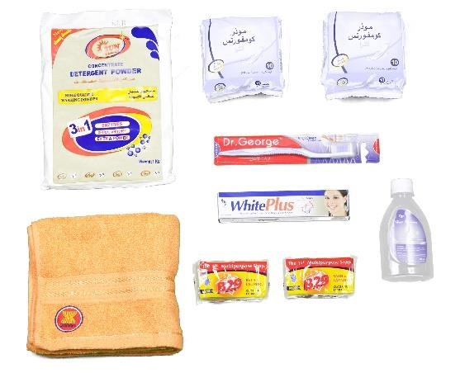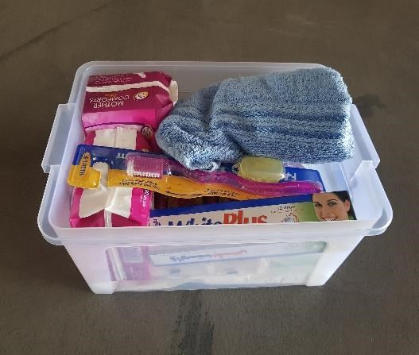

Picture
SHIPPING INFORMATION | Length: 289 mm Net Weight: 2.5 kg  Width: 213 mm Gross Weight: 3 kg  Height: 187 mm Volume:
GENERAL INFORMATION | Hygiene kit is an essential emergency non-food item supplied in the first phase of an emergency to fulfil the basic hygiene needs per person. Contents:  - Laundry Powder 1kg x 1 pc  - Sanitary Pad 8pcs/pack x 2 packs  - Hand Towel 1 pcs size 70 x 35 cm  - Tooth Brush 1 pcs  - Tooth Paste 75ml x 1 pc  - Soap (bath and laundry) 150g x 2 pcs  - Hair Shampoo 250ml x 1 pc  - Plastic Container x1 pc  All final artwork for the boxes and shipping mark of the stockpile/relief items should be prior approved by the AHA Centre before the selected vendor produce them
TECHNICAL INFORMATION | Materials: NA  Size: NA  Unit: kit

Categories: |  | OSM
Product Code: |  | MSU-01
Product Name: |  | Mobile storage unit 10x24m – Aluminium structure
 |  |  |  | Picture
SHIPPING INFORMATION |  |  |  |  | Net Weight:
 | Frames are packed in bundles: The bundles are 8 whereas the PVC covers and all fixtures are packed in two wooden boxes.  are packed in two wooden boxes. |  |  |  | Gross Weight: |  |  | 1990 kg
 |  |  |  |  | Volume: |  |  | 5,73 M3
GENERAL INFORMATION
MSU (Mobile Storage Units) are ideal for shipping as they are modular and can be Transported in standard ISO container. 4 to 6 hours and a team of 6 people. A MSU is required in situations where a large storage capacity is required, and where no existing building is available. Item Details:
Made of Aluminium, are ideal for air transport due to low; weight compared to the old steel version. It can be equipped with many options that can be ordered such as: flooring system (soft or hard), dehumidification system, internal lighting system etc)
TECHNICAL INFORMATION
 | Materials: | Low density polyethylene (LDPE)Sheet, extra UV protection
 | Size: | LxW = 10x24 m (Side Height: 3 m; Gable Height = 5,5 m; Arch distance=4 m
 | Unit: | Kit
 | Source: | Made in Norway
 | Brand: | Equivalent to O.B. Wiik

Categories: |  | OSM
Product Code: |  | WFM
Product Name: |  | Manual Water Filtration + Pump
 |  |  |  | Picture
SHIPPING INFORMATION |  |  | Length: | 120 cm | Net Weight: |  | 60 kg
 |  |  | Width: | 80 cm | Gross Weight: |  | NA
 |  |  | Height: | 100 cm | Volume: |  | 0,96 M3
GENERAL INFORMATION
 | In many disasters, contaminated water remains a critical issue. StepPure™ is a portable,500L/h water filtration system designed to allow more victims of natural disasters access to clean and safe water for consumption and survival.
TECHNICAL INFORMATION
 | Materials: | NA
 | Size: | LxWxH = 45x35 100 cm respective items (Filtration and Pump set)
 | Unit: | Kit
 | Source: | info@goldenseason.com.sg or +65 68632228
 | Brand: | Equivalent to

Categories: |  |  |  | OSM
Product Code: |  |  |  | WFA
Product Name: |  |  |  | Automatic Water Filtration
 |  |  |  |  |  |  |  | Picture
SHIPPING INFORMATION |  |  |  |  |  | Length: |  | 426 mm |  | Net Weight: |  |  |  | 33 kg
 |  |  |  |  |  | Width: |  | 360 mm |  | Gross Weight: |  |  |  | NA
 |  |  |  |  |  | Height: |  | 930 mm |  | Volume: |  |  |  | 0,24 M3
GENERAL INFORMATION
In many disasters, contaminated water remains a critical issue. AutoPure™ is a portable, 420L/h water filtration system designed to allow more victims of natural disasters access to clean and safe water for consumption and survival.
The electrically powered system is easy to operate and is turned on / off with a switch. To operate, the user simply connects the system to a 12V Car battery to power the system, set the valves to the correct settings, and turn on the switch. The system runs on DC current and can be powered by alternative 12V DC sources.
TECHNICAL INFORMATION
 |  | Materials: |  | NA
 |  | Size: |  | LxW xL = 45 x 35 x 100 cm
 |  | Unit: |  | Kit
 |  | Source: |  | info@goldenseason.com.sg or +65 68632228
 |  | Brand: |  | Equivalent to
Categories: |  |  | OSM
Product Code: |  |  | GEN-02
Product Name: |  |  | Generator, diesel, 16 Kva, wheel-mount.
 |  |  |  |  |  |  | Picture
SHIPPING INFORMATION |  |  |  |  | Length: |  | 130 cm |  | Net Weight: |  |  |  | 320 kg
 |  |  |  |  | Width: |  | 64 cm |  | Gross Weight:
 |  |  |  |  | Height: |  | 86 cm |  | Volume: |  |  |  | 0,660 M3
GENERAL INFORMATION
The generator shall be connected to the grid so that when the power outage could take place the generator will be activated. Europower open generating sets with Kubota water-cooled diesel engines, 3000rpm, 50Hz, 4 stroke engine. Power: 16.4kW (3000rpm), 3-Cylinder Diesel,
Water-cooled, Displacement: 1123cm3, Consumption @75% load: 4.5 lts/hours
Tank: 55 ltrs, Autonomy @75% load: 12.2 ltrs, Noise level: 81dB(A)@7m = LWA (*)
TECHNICAL INFORMATION
 | Materials: |  | NA
 | Size: |  | LxWxH = 130 x 64 x 86 cm
 | Unit: |  | Piece
 | Source:
 | Brand: |  | Equivalent to Kubota

Categories: |  | OSM
Product Code: |  | PLT-ET
Product Name: |  | Plastic Pallet – American
 | 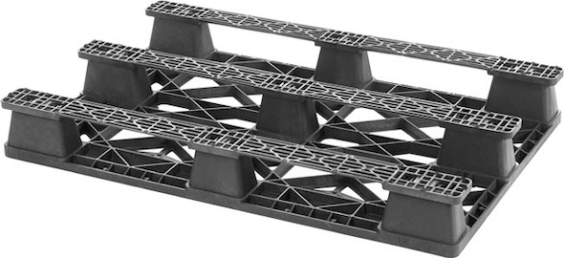
 |  |  |  | 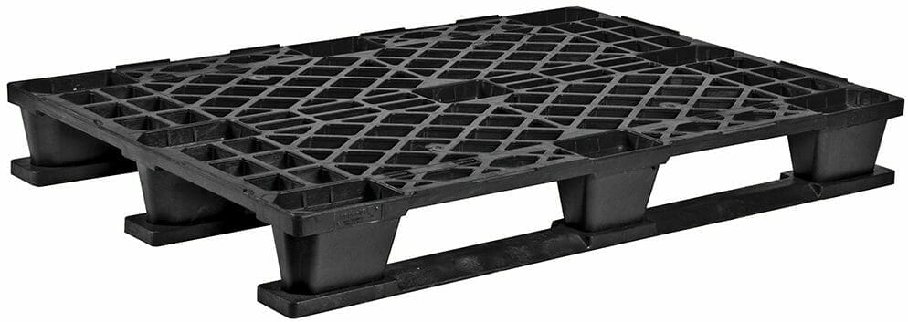
 |  |  |  | Picture
SHIPPING INFORMATION |  |  | Length: | 120 cm | Net Weight: |  | 6,5 - 9 kg
 |  |  | Width: | 100 cm | Gross Weight:
 |  |  | Height: | 14 cm | Volume: |  | 0,1344 M3
GENERAL INFORMATION
STATIC LOAD: stat. 2700 kg | dyn. 900 kg (9F)
stat. 3600 kg | dyn. 1200 kg (3R) DYNAMIC LOAD: 2000 KG
TECHNICAL INFORMATION
 | Materials: | HDPE Pipe
 | Size: | LxWxH = 1200x100x140 mm
 | Unit: | Piece
 | Source: | NA
 | Brand: | Market Available
 | Price:

The Artwork of the box
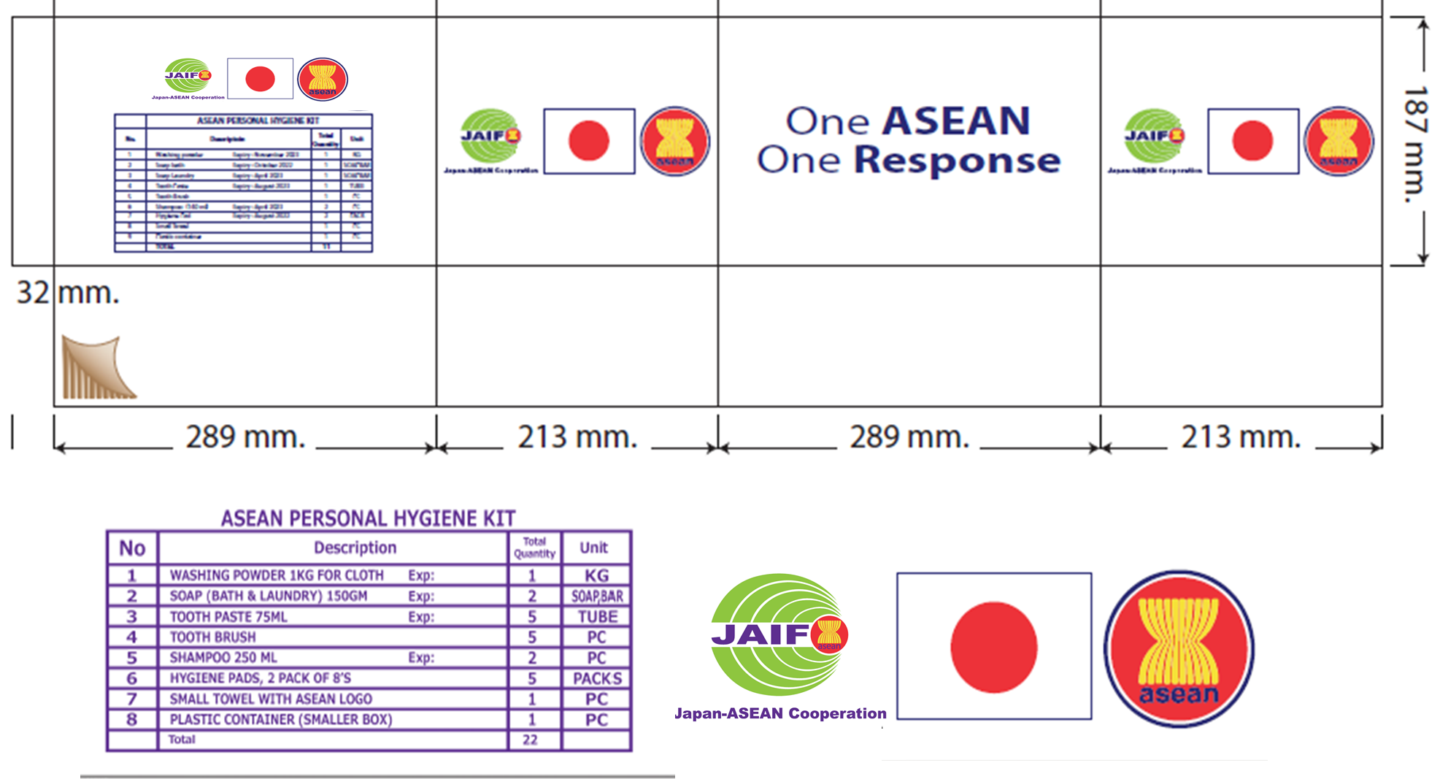

Appendix 2:

Technical Offer based on Technical Specifications
The AHA Centre Requirements  (minimum) | Supplier’s Product Specifications
LOT 1: Operation Support Material - OSM
Mobile Storage Unit – MSU 10x24 s.q.m
See Appendix 1
LOT 2: Operation Support Material - OSM
Diesel Generator 16, Kva 1 Phase, Wheel Mount See Appendix 1
Water Filtration Automatic
See Appendix 1
Manual Water Filtration + Pump
See Appendix 1
LOT 3: Operation Support Material - OSM
Plastic Pallet, American Pallet
See Appendix 1
LOT 2: Beneficiary Support Material – BSM
Family Kit
See Appendix 1

Toolkit Shelter
See Appendix 1
Personal Hygiene Kit
See Appendix 1

Tarpaulin 4x60 M
See Appendix 1

Please provide additional sheets as necessary to include photos and proposed technical specifications

Appendix 3:

Supplier Questionnaire

Publication reference: AHA-T/2021/November/T-011

Company Name:
Company Address:
Contact Name:
Contact Position / title:
Contact Details (Phone / Email):

Company Information:
1 | Is your company registered in Philippines?  Please provide a copy of Registration.
1a | If not, where is your company registered?
2 | When was it registered?
3 | Is your company part of an international company?
4 | Do you have other offices / plants in the country? Where?
5 | How many employees work for your company in-country?
Financial Information:
6 | What is your yearly income in USD over the last 2 years?
6a | Last Year (2021):
6b | Previous Year (2020):
7 | Can you provide audited Financial accounts upon request?
Customer References:
8 | Have you worked in the past with the AHA Centre (detail year and activity)? If yes, please provide details below
8a | Title of Contract Year Amount (USD)
9 | Please provide names and contacts of 3 customers to whom you have recently provided the same kind of products / services with similar value of contract | 1.  2.  3.
9a | Customer (company) Name Contact Name Address Contact No & Email
Technical Capacity:
10 | What is your core activity?
11 | What other products / services do you offer?
12 | Are you the manufacturer of the products presented in the offer?
12a | If yes: where is the manufacturing site located?
12b | If no, are you an official reseller for these products?  Please provide a copy of Dealer Registration.
13 | Do you currently have stocks?
13a | If yes, where are they located
Delivery Capacity:
14 | Can you hold dedicated stocks for your customers?
15 | Can you manage delivery to the AHA Centre DELSA Satellite Warehouse in Camp Aguinaldo, Quezon City, Philippines?
16 | What is your average lead time for delivery to the designated location after receipt of the AHA Centre Purchase Order/Contract?
17 | Do you have your own trucks / drivers for delivery?
17a | If not, how will you deliver the items to the designated  delivery location?
17b | If you have a designated transport company, please provide the name and address and contact number
Financial Conditions:
18 | What is the validity of your offer? (Minimum 60 days)
19 | If you get awarded the Contract, will you offer fixed prices for 4 months?
20 | Do you have an official receipt or invoice?

Appendix 4:

Detailed Pricing Matrix
Supplier Name:
Address:
Telephone:
Fax:
Website:
Contact Person:
Telephone/Mobil Phone:
Email:

LOT: 1 | Operational Support Material - OSM
ITEM  (Specification as detailed on Appe. 1) |  | Qty | UoM | Unit Price in USD | Total Unit Price in USD
Mobile Storage Unit (MSU) 10 x 24 s.q.m |  | 1 | Set
LOT: 2 | Operational Support Material - OSM
ITEM  (Specification as detailed on Appe. 1) |  | Qty | UoM | Unit Price in USD | Total Unit Price in USD
Diesel Generator Diesel, 16 Kva 1 Phase, wheel-mount |  | 1 | Pc
Water Filtration automatic |  | 1 | Set
Water Filtration Manual + Pump |  | 1 | Set
LOT: 3 | Operational Support Material - OSM
ITEM  (Specification as detailed on Appe. 1) |  | Qty | UoM | Unit Price in USD | Total Unit Price in USD
Plastic Pallet (American Type) |  | 427 | Pc
LOT: 4 | Beneficiary Support Material – BSM
ITEM  (Specification as detailed on Appe. 1) |  | Qty | UoM | Unit Price in USD | Total Unit Price in USD
Family Kits |  | 2,700 | Kit
Personal Hygiene Kits |  | 13,000 | Kit
Tarpaulin 4x60 m |  | 1,000 | Kit
Toolkit Shelter |  | 2,700 | Kit

All other information that we have not provided automatically implies our full compliance with the requirements, terms and conditions of this Tender.

[Name and Signature of the Supplier’s Authorised Person]
[Designation]
[Date]

Appendix 5:

The AHA Centre’s Good Business Regulations

These Good Business Regulations are the ground for a professional working relationship between the AHA Centre and the Tenderer.

They are general regulations valid unless other particular conditions are mentioned in the contract. In case of conflicting terms within documents, the conditions of the contract or tender dossier will prevail on these Good Business Regulations.

Principles of the procurement procedures

The AHA Centre has transparent procedures to award markets. Essential principles are
- Transparency in the procurement process
- Proportionality between the procedures followed for awarding contracts and the value of the markets
- Equal treatment of potential Suppliers

Usual criteria to select a Supplier are:
- Authorisation to perform the market
- Financial and economic capacities
- Technical expertise
- Professional capacities

Usual criteria to award markets are:
- Automatic award (the cheapest offer complying with all requirements)
- Best value for money (price/quality ratio)

Misbehavior, ineligibility and exclusion

The AHA Centre considers the following misbehaviour as a valid ground for a systematic exclusion of an awarding market procedure and for the termination of all working relationship and contracts:
- Fraud defined as any intentional act or omission relating to:
  - The use or presentation of false, incorrect or incomplete statements or documents, which has as its effect the misappropriation or wrongful retention of the AHA Centre or institutional donors’ funds
  - Non-disclosure of information, with the same effect
  - The misapplication of such funds for purposes other than those for which they were originally granted
- Active corruption: to deliberately promise or give an advantage to an official for him/her to act or refrain from acting in accordance with his/her duty in a way which damages or is likely to damage the AHA Centre or institutional donors financial interests
- Collusion: the co-ordination of firm competitive behaviour, with the likely result that prices rise, output is restricted and the profits of the colluding companies are higher than they would otherwise be. Collusive behaviour does not always rely on the existence of explicit agreements between firms, but can also be tacit.
- Coercive practice: harming or threatening to harm, directly or indirectly, persons, or their property to influence their participation in a procurement process or affect the execution of a contract.
- Bribery: to offer the AHA Centre employees monetary or in-kind gifts in order to gain additional markets or to continue a contract
- Involvement in a criminal organisation or any other illegal activity established by a judgement, by the US Government, the European Union, the United Nations or any other donor funding the AHA Centre.
- Immoral Human Resources practices: exploitation of child labour and the non-respect of basic social rights and working conditions of employees or sub-Suppliers

The AHA Centre will exclude from a procurement procedure any candidate or tenderer falling into one of the following cases:

- To be bankrupt or to be wound up, to have affairs administered by the courts, to have enter into an arrangement with creditors, to have suspended business activities, to be the subject of proceedings concerning those matters, or are in any analogous situation arising from a similar procedure provided for in national legislation or regulations
- To have been convicted of an offence concerning professional conduct by a judgement that has the force of res judicata
- To have been guilty of grave professional misconduct proven by any means that the AHA Centre can justify
- To have not fulfilled obligations relating to the payment of social security contributions or the payment of taxes in accordance with the legal provisions of the country in which they are established or with those of the country where the AHA Centre mission is operating or those of the country where the contract is to be performed
- They have been the subject of a judgement that has the force of res judicata for fraud, corruption, involvement in a criminal organisation or any other illegal activity detrimental to the Communities' financial interests
- To have been declared to be in serious breach of contract for failure to comply with their contractual obligations in another previous procurement procedure

The AHA Centre will not award contracts to candidates or tenderers who, during the procurement procedure:
- Are subject to a conflict of interest
- Are guilty of misrepresentation in supplying the information required by the AHA Centre as a condition of participation in the contract procedure or fail to supply this information

Administrative and financial sanctions

In the event a Supplier, candidate or tenderer is engaged in corrupt, fraudulent, collusive or coercive practices the AHA Centre will impose:

- Administrative sanctions:
Administrative sanctions are the official notification of the misconduct to the relevant civil or commercial authorities and the immediate termination of all existing working relationships.

- Financial sanctions:
The AHA Centre will request the reimbursement of the cost linked directly and directly to the conduct of a new tendering process or market award. If any, the tender or performance guarantee will be kept by the AHA Centre.

Information of and access for the Donors

The AHA Centre will inform immediately the Institutional Donors and will provide all the relevant information in the event a Supplier, candidate or tenderer is engaged in corrupt, fraudulent, collusive or coercive practices.
Furthermore, the Suppliers agree to guarantee a right of access to their financial and accounting documents to the representatives of the AHA Centre’s institutional donors for the purposes of checks and audits.

Documents to be a Supplier

Hereafter is the minimal documentation a Supplier working with the AHA Centre will have to provide:
- Personnel national ID document of the Supplier/company representative
- Status and registration of the company
- Mission order or power of attorney authorising the representative to contact
Important note: Additional documentation may be required for a particular market.

In addition, the Supplier must have the capacity to issue invoices, receipts and waybills (or delivery notes), to provide a tax clearance certificate and certify documents with an official stamp.

Anti-Corruption Policy

If you believe that the action of anyone (or a group of people) working or volunteering for the AHA Centre programs is responsible for violating the above rules, you should file a report through the Whistle-blower Email Hotline.
In order to enable the treatment, reports should give as precise information as possible; your name and contact are optional but encouraged. All reports are treated confidentially to the extent permissible by law.

Note: “Declaration of compliance & commitment to respect the AHA Centre Good Business Regulations“ on the next page.

Declaration of compliance & commitment to respect the AHA Centre Good Business Regulations

TO BE FILLED OUT BY THE BIDDER
I, undersigned …………representative name………. representative of …company name……… certified that I have read and understood these regulations.
On behalf of the company I act for, I accept the terms of the AHA Centre Good Business Regulations and I commit to achieve the best performances in the event ………….company name………… is awarded a market.

By signing, I certify that ………….company name………… has not provided, and will take all reasonable steps to ensure that it does not and will not knowingly provide material support or resources to any individual or entity that commits, attempts to commit, advocates, facilitates, or participates in fraud, active corruption, collusion, coercive practice, bribery, involvement in a criminal organization or illegal activity, or immoral Human Resources practices, such as the use of Child labour or overriding basic social rights and work conditions or the standards defined by the International Labour Organisation (ILO), particularly in terms of non-discrimination, freedom of association, payment of the legal national minimum wage, no forced labour, and the respect of working and hygiene conditions .

Last, I hereby certify that ………….. company name …..……. is not involved in any pending lawsuit, claim or action in the Company’s name, or on behalf of any other person or entity, against the Company, regarding fraud, corruption, bribery or any illegal activity, and has not been convicted guilty of such practices at any time.

All the Supplier’s responsibilities mentions in this document extend to any Supplier affiliates and subsidiaries.

Name: Date:

Position: Stamp:

Signature:

